**Chapter I**

**Introduction**

In relation with this study Carlos Hilado Memorial State College and extensions is one of the progressing institution. In order to cope with its progression, the proponents proposed a well-designed computerized program or information system to online signing of clearance since technology in general and computers in particular have become the most used tool in all fields. Clearance is a status granted individuals or permission for something to be done. Faculty should be cleared from all accountabilities or requirements need to process in the institution with other departments. Online Faculty Clearance System will help ease queuing system in the institution clearance process. The designed system will serve as a more reliable and effective means of undertaking faculty clearance remove all forms of delay and stress as well as enable them to understand the procedure involved since it is a web-based system.

**1.1 Project Context**

The main target of this study is build a system that will provide a fast and reliable solution for the processing of the faculty clearance. Also, it manages the requirements in order for the faculty to be cleared. The faculty in the main and other campuses of Carlos Hilado Memorial State College will benefit in this study by improving the process from manual to web-based. Moreover, Carlos Hilado Memorial State College and the extensions (Alijis, Binalabagan, Fortune Towne) of the college with different designee such as, Department of Accountant, Supply Officer, Director, Physical Plant-Facilities, FACFED/Campus Faculty Club President, Chairman Cooperative, College Librarian, Registrar, Area Chairman, Dean of the College, Executive Director, Human Resource Mgt. Officer III, Chief Administrative Officer, Vice-President for Administration, Vice-president for Academic Affairs and Head of the Agency/SUC President will be aided in this study. The procedure of clearance signing will be followed, only that this system will automate it.

The SDLC that the proponents will be using on this project is Rapid Application Development which is a type of incremental model. This model relies on prototyping to speed up the development and elicit feedback from the users. RAD model will help reduce in the development time and quick initial reviews to solve integration issues of Online Faculty Clearance System.

The scope of the study includes the online processing of faculty’s clearance where the target users are the faculty and the designated department of the four campuses of Carlos Hilado Memorial State College. Faculty is able view the clearance status, upload and download documents while the designee will approve the completed requirements of the faculty. This will be developed within 2-3 months as the timeframe of the proponents. Hypertext Preprocessor (PHP), Java Script, jquery, CS5, CSS, Bootstrap are used to construct this system and the database for the software is MySQL.

**1.2 Problem Statement**

The general problem of this study is the slow processing of traditional Faculty Clearance of Carlos Hilado Memorial State College and the other campuses.

Specifically, this study has the following sub-problems:

1. Time consuming due to the manual processing of checking documents for the clearance signing.
2. Unavailability of designee who will sign the clearance.
3. Clearance prone to lost
4. Damaged clearance form

**1.3 Definition of Terms**

The proponents defined the following terms operationally base on their use in the study and the system.

**Online**. Webpage for downloading/uploading documents of the faculty.

**Clearance**. A requirement to be processed by the faculty to be cleared and approved by the designee.

**System.** Is the collection of the faculty information in processing of clearance.

**Chapter II**

**Review of Related Literature and Systems**

This chapter discusses the Related Literature and Systems that are found helpful and inspirational for the development of Online Faculty Clearance System.

**2.1 Review of Related Literature (Local, National, International)**

**NBI Clearance (Bacolod City)**

According to lawyer Ferdinand Lavin a chief of the International Operations Division, said in Bacolod City that the NBI continues to implement the one-year validity period of the clearance, but they will try to shorten the process. He added that the agency will require two valid government-issued identification cards for verification of personal information. He admitted that they are having regional and district offices, in terms of connectivity as the agency’s operation is internet-based, specifically in checking criminal records. Ferdinand Lavin also said that the NBI is really trying to improve its system in line with the directive of President Rodrigo Duterte to shorten the process in government transactions in order to cut red tape. The online processing helps minimize errors on the personal details being filled out by the one processing the clearance. Otherwise the problem of congestion where the agency is also working on upgrading its facilities as part of the provisions of the Modernization Law signed by former President Benigno Aquino III. (http://www.sunstar.com.ph/bacolod/local-news/2016/07/19/nbi-works-addressing-clearance-processing-woes-486182)

**Phil Army automates clearance process**

The Philippine Army Automated Clearance System (PAACS) intends to enhance the fast and reliable issuance of security and command clearances to all active military and civilian personnel in the Philippine Army. It undergone a series of test runs and was conceptualized in 2012 that Headquarters Philippine Army interlinking the information systems of the Discipline, Law and Order Branch of the Office of the Chief of Staff for Personnel, OG1; Office of the Army Adjutant; Counter Intelligence Branch, Office of the Assistant Chief of Staff for Intelligence, OG2; and the Clearance Workstation of OG2, Headquarters and Headquarters Support Group. It is not only economical, but also efficient, fast, reliable and secure implementation of the Automated Clearance System. Philippine Army continues to implement organizational reforms in terms of policies, systems and procedures. Once implemented, the clearance process will set the standard in the Security Management. (http://www.army.mil.ph/pr/2014/sep/010914.html)

**OPM’s security clearance system**

US Office of Personnel says they’re enabling user access to e-QIP. The system used to process information forms. Twenty one million people still remain unprotected from whom over stole their U.S Office of Personnel Management (OPM) records, but they announce of its repair. E-QIP is a web-based platform used to complete and submit background investigation forms for security clearances. Acting OPM director Beth Cobert wrote in a memo to other Federal government agencies that, "Given the limited resources available to OPM at this time to deal with a contract of this size, agencies will be asked to contribute 2015 funding to cover the first full year's costs of credit monitoring and related services / benefits" for the incident.". The use of this system will help secure each information of the individual people. (www.zdnet.com/article/u-s-security-clearance-system-is-sort-of-kind-of-online-again/)

**2.2 Review of Related Systems (Local, National, International)**

**Automated Student's Clearance System**

St. Bridget College Batangas is a Catholic evangelizing educational institution founded by the Religious of the Good Shepherd inspired by the compassion of Jesus, and the zeal of St. John Eudes and St. Mary Euphrasia. Their studies objective is to provide good service to the students and minimize the time consume. Implement policies and procedures relative to admission, registration and graduation of students. Serve as recorder and keeping student records. Aside from the teachers they also have staff from the Registrar’s Office, Staff from the guidance Office, Staff form the library and Staff from the Finance Office assigned to approve the clearance. If the system will be a good help for the institution? "Yes, it will be a great help for us. So we can lessen the time consumed in finishing their clearance." - Mrs. Elveña (by [Jezreel Besa](https://prezi.com/user/h6pjksgu_oxi/) on 22 September 2013). (www.https://prezi.com/wp0xeocqehur/clearance-system/)

**Student Clearance System (DLSU)**

The Centralized Student Clearance System was maintaining by the Office of the University Registrars. Otherwise, to indicate that a student is put “on hold,” a formal letter (signed by the office/unit head) must be submitted to the Office of the University Registrar, requesting a student(s) be “on hold.” To clear a student, a formal letter (signed by the office/unit head) must be submitted to the Office of the University Registrar, requesting a student(s) be “cleared.” It is important to remember that a student put "on hold" remains as such until a request for clearance is received from the concerned office/unit. Requests for “hold” which are related to discipline matters should be addressed to the Student Discipline Formation Office (SDFO), which has the facility to make entries to the centralized student clearance system. (Ms. Grace Panaglima Ext. 115(2012)). (www.dlsu.edu.ph/offices/registrar/policies/studentclearance.asp.)

**Online Clearance System for Tertiary Institutions: Tai Solarin University of Education, Ogun State, Nigeria**

The system proposed was online based research work that will help ease the queuing system in the university’s clearance process. Primary aim in developing is to replace the manual/file method of processing clearance. The implementation of the computer based system was carried out using, PHP Language, HTML, CSS and the database for the software is MySQL. The admission process of students is done online and the presence of the student is needed for the admission of clearance. Some system bases to the other universities where the process of students is strictly done online like Ambrose Alli University physical presence of admitted candidates is not required in the university premises during the clearance exercise as it is strictly online. On the other hand other private organizations defined “clearance” which is refer to the authorization or permission from an authority (Anigbogu, 2000; Chimezie, 2000; Wikipedia 2013). The act of clearing an individual involves granting individual a permission to have access to sensitive or secret documents or other information. The Oxford dictionary defines “online” as controlled by or connected to a computer and as an activity or service which is available or performed using the internet or other computer network (Dictionary of British and World English, 2015). (www.researchgate.net/publication/303543627_design_and_Development_of_online_clearance_system_for_Tertiary_institutions_A_case_Study_of_Tai_Solarin_University_of_Education_Orgun_State_Nigeria)

**2.3 Summary**

|  |  |  |
| --- | --- | --- |
| **Related Systems** | **Features** | **Proposed Systems** |
| Automated Student's Clearance System | * Provide good service to the students * Minimize Time | * To Process Effectively and Efficiently Faculty Clearance with an accurate data. |
| Student Clearance System (DLSU) | * Proper way of processing student clearance by the designated offices. | * The step by step process before proceeding to the next assigned faculty. |
| Online Clearance System for Tertiary Institutions: Tai Solarin University of Education, Ogun State, Nigeria | * Processing of clearance online/ Manual to automated. | * Adopt the same features needed for the Online Faculty Clearance. |
| Ghana Integrated Cargo Clearance System (GICCS) | * Manifest submission and payment related processing. * Declaration submission, validations, notifications and payment related processing. * Logistics module has Cargo Tracking, Container transfer, Delivery Order Submission and Tracking features. | * Online submission of Faculties requirements. * Accurate information of queuing clearances. |

**Chapter III**

**Methodology**

This chapter includes the research method and procedures prepared by the proponents in order to develop Online Faculty Clearance System for the four campuses of Carlos Hilado Memorial State College. This comprises the recommended hardware and software requirements, the conceptualization and the research approach used. It will also include an overview of how to treat research data gathered by the proponents.

**3.1 Research Approach**

The proponents used Qualitative Research where ‘observation’ as a strategy used by the researchers to investigate the problems, and Action Research since real situations was basis for real problem solutions (Cassell & Symon, 2010). Observation is useful for generating in-depth descriptions of organizations or events, for obtaining information that is needed. It contrasts by means of most fundamental type of data gathering method in which person give their own point of view based on what they sees and understands. This method helps the proponents to understand more about the development of Online Faculty Clearance System. Also, proponents conduct an ‘interview’ with the other faculty to know the manual flow of clearance signing. Before conducting the interview, proponents ask permission to the faculty and prepared a guide question in order to control the flow of conversation that will gather all necessary information. The proponents identified the problems existing within the manual process and found an opportunity to solve these problems by proposing the Online Faculty Clearance System.

**3.2 Systems Development Methodology**

Systems Development Life Cycle (SDLC) is a conceptual model used in project management that describes the stages involved in an information system development project (Rouse 2009). It is the process of creating or altering software systems, and the models and methodologies that people use to develop these systems.

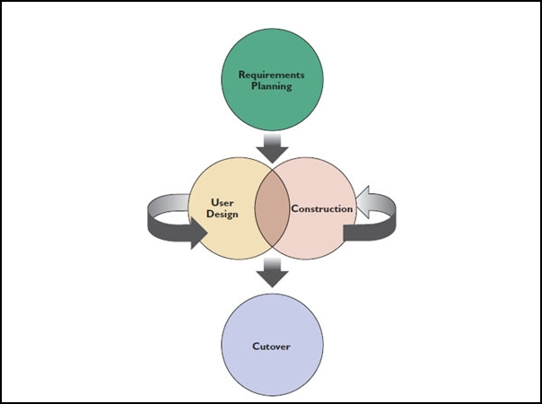The proponents will used the Rapid Application Development in developing the system (diagram as shown in Fig.1). RAD is also a team-based technique that speeds up information systems development and produces a functioning information system. The Iterative process continues until the system is completely developed and users are satisfied. The RAD model consists of four phases: requirements planning, user design, construction, and cutover, as shown in Figure 1. There is continuous interaction between the user design and construction phases.

Figure 1. Rapid Application Development Methodology

**Requirements Planning**

In this phase, the proponents first identify the requirements and specifications that the system requires in order for it to be understood. The proponents also do the documentation analysis in which secondary sources such as online journals, books and websites are being gathered, documented then synthesized the information. Online Faculty Clearance System is proposed that will ease the process and minimize problems in clearance signing. Additionally, the weakness of the system is modified where administrator, designee and faculty cannot access the system without internet connection.

**User Design**

During the design phase of the RAD model, the proponents distinguish the design and functionalities of Online Faculty Clearance System.

**Construction**

It is one of the most fundamental phase where the programmer start coding the proposed system. The development of the Online Faculty Clearance System is based on the design presented by the proponents.

**Cutover**

This phase indicates the deployment stage. It covers the implementation of the system where it is being tested to ensure that it is running correctly. The proponents conducted an evaluation to know if the system meets the requirements of the institution.

**3.3 System Requirement Specification**

**Functional Requirements**

The Online Faculty Clearance System involves faculty, designee and administrator in order the system to function. Clearance will be process online by the faculty which the data given are the basis if they are already cleared. Administrator has the access in the system to undertake the clearance. Otherwise the Online Faculty Clearance System will have the following functionalities.

**Administrator**

* Add/Edit/Remove Faculty
* View Faculty Profile
* View Designee approval
* Manipulate Clearance of the faculty

**Designee**

* Assign Faculty Requirements
* Approve Faculty Clearance
* View list of Faculty in the Department

**Faculty**

* Upload/Download Requirements
* View clearance status/progress

**Input Requirements**

**For admin Admin ID and Password**

The Admin ID is needed while password will be provided to the administrator to access the system and manipulate faculty clearance. The administrator is responsible for the integrity and security of the end user.

**For the Designee**

Username and Password is required to log in in the system and approved the faculty clearance.

**For the Faculty**

Faculty ID is required to log in in the system. Confirmation of faculty ID by the administrator allows the faculty to access the system. The Faculty cannot access the system without faculty ID confirmation.

**Output Requirements**

**Downloadable Clearance**

An output generated in processing of the clearance. The file document can be downloaded by the faculty to have their own copy. All done clearances will be saved in a single or a zipped file where authorized person is permitted to access it.

**Reports**

Reports include all the names of the faculty who are already cleared and uncleared in the institution.

**3.4 System Analysis**

The system analysis help the proponents to continually learn new techniques and approaches to properly capture, maintain, understand and develop efficient and effective systems (Reema Al-Kamha n.d.). Carlos Hilado Memorial State College as one of the progressing State College in the province. The school must need to be modernize and competitive in terms of providing efficient and automated process for the faculty of the four campuses of Carlos Hilado Memorial State College.

**Data analysis**

This section discusses the study of data collection process, data storage and manipulations in the proposed Online Faculty Clearance System, the administrator have the authority to manipulate the system. All data entered by the administrator will be stored in the system’s database.

**Process analysis**

Carlos Hilado Memorial State College and extensions are still in manual processing of faculty clearance signing. In this case the proponents proposed the Online Faculty Clearance System that could generate clearance in a fast and reliable process. In order to access the system, the administrator has administrator ID and password to manipulate and maintain the security of the system. Each Designee of the Carlos Hilado Memorial State College and the extensions is responsible for the approval of the faculty clearance. The faculty is allowed to view the progress status of the clearance. The process of Online Faculty Clearance Signing is shown in figure 2.

**Data Dictionary**

The following tables contain the list of all fields included in the tables in the database. Also displayed are the properties and a brief description of fields.

**Table 1: FACULTY**

|  |  |  |  |  |  |
| --- | --- | --- | --- | --- | --- |
| **Field Name** | **Optional** | **Field Type** | **Length** | **Key** | **Description** |
| faculty_id | N | INT | 5 | PK | Faculty ID number given |
| Fname | N | VARCHAR | 15 |  | First Name of the faculty |
| Mname | N | VARCHAR | 15 |  | Middle Name of the faculty |
| Lname | N | VARCHAR | 15 |  | Last Name of the faculty |
| Birthdate | N | INT | 8 |  | Birthdate of the faculty |
| Age | N | INT | 3 |  | Age of the faculty |
| Contact_no. | N | INT | 20 |  | Mobile Number of the faculty |
| Gender | N | VARCHAR | 6 |  | Gender specification of the faculty |
| Email | N | VARCHAR | 30 |  | Email Address of the faculty |
| Designation | N | VARCHAR | 10 |  | Faculty Job Status |
| req_id | N | INT | 5 | FK | System Generated Sequence Number of Requirements |
| dep_id | N | INT | 5 | FK | Department ID |

**Table 2: REQUIREMENT_STATUS**

|  |  |  |  |  |  |
| --- | --- | --- | --- | --- | --- |
| **Field Name** | **Optional** | **Field Type** | **Length** | **Key** | **Description** |
| reqstat_id | N | INT | 5 | PK | System Generated Sequence Number of Requirement Status |
| status | N | VARCHAR | 10 |  | Requirement status of the faculty |
| faculty_id | N | INT | 5 | FK | Faculty ID number given |
| req_id | N | INT | 5 | FK | Requirements ID |

**Table 3: ADMIN**

|  |  |  |  |  |  |
| --- | --- | --- | --- | --- | --- |
| **Field Name** | **Optional** | **Field Type** | **Length** | **Key** | **Description** |
| admin_id | N | INT | 5 | PK | Generated ID Number of the admin |
| Password | N | VARCHAR | 15 |  | Passsword of the Administrator |
| dep_id | N | INT | 5 | FK | Department ID |

**Table 4: REQUIREMENT**

|  |  |  |  |  |  |
| --- | --- | --- | --- | --- | --- |
| **Field Name** | **Optional** | **Field Type** | **Length** | **Key** | **Description** |
| req_id | N | INT | 5 | PK | System Generated Sequence Number |
| req_content | N | VARCHAR |  |  | Requirement content |
| admin_id | N | INT | 5 | FK | Generated ID Number of the admin |

**Table 4: DEPARTMENT**

|  |  |  |  |  |  |
| --- | --- | --- | --- | --- | --- |
| **Field Name** | **Optional** | **Field Type** | **Length** | **Key** | **Description** |
| dep_id | N | INT | 5 | PK | Department ID |
| dep_name | N | VARCHAR | 15 |  | Department Name of the Offices |
| designee | N | VARCHAR | 15 |  | Assigned person in the department |
| req _id | N | INT | 5 | FK | System Generated Sequence Number |
| faculty_id | N | INT | 5 | FK | Faculty ID number given |

**3.5 Design**

**Flow Chart**

The figure below (Fig.2, Fig.3, Fig.4) shows the systematic process of the Admin, Designee and Faculty in the Online Faculty Clearance System.

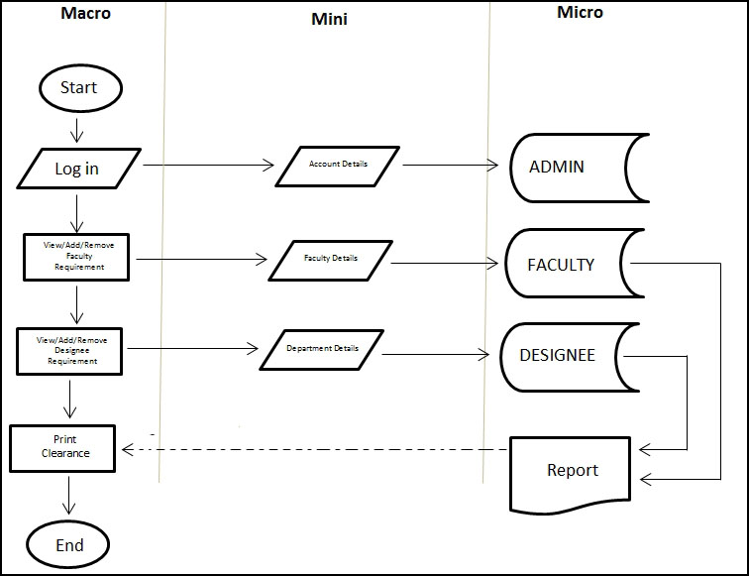

**Figure 2. Admin Flow Chart**

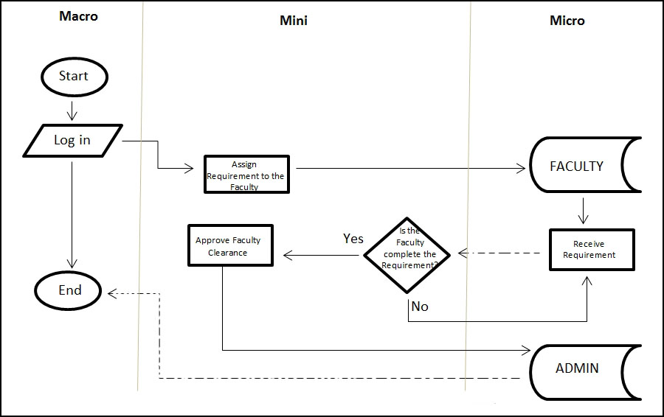**Figure 3. Designee Flow Chart**

**Figure 4. Faculty Flow Chart** 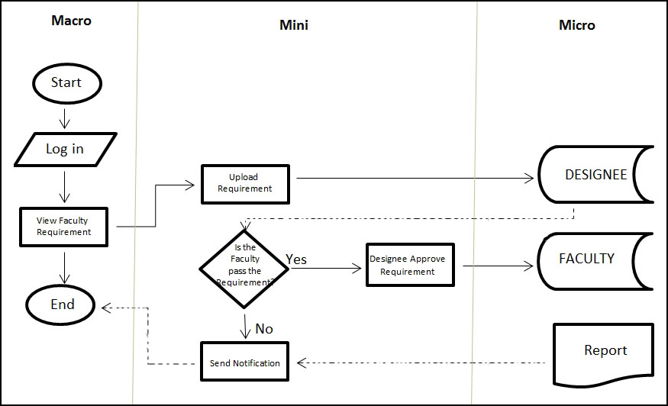

**Data Flow Diagram**

**Context Data Flow Diagram**

The context data flow diagram shows the entire process of Online Faculty Clearance System. Faculty, Designee and Admin serve as the external entity while the center part represents the incoming and the ongoing process. Faculty get the remaining requirements needed then comply in order to be cleared and clearance to be sign. Designee will manage the requirements of the faculty and approve it. Admin is responsible for the cleared clearance to be produce.

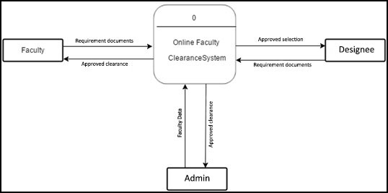

**Figure 3. Context Data Flow Diagram**

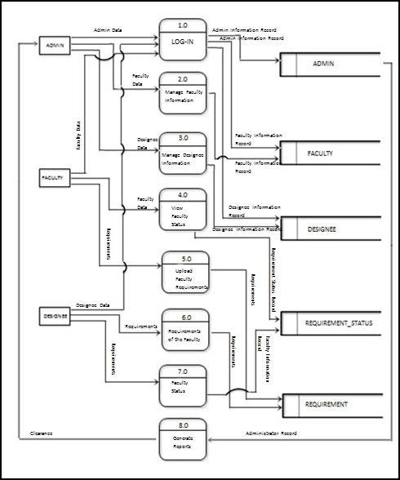

**Figure 4. Level 0 Data Flow Diagram**

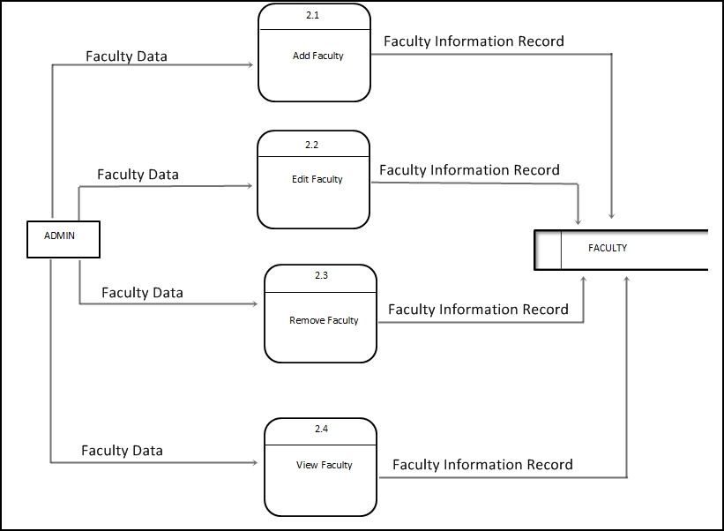

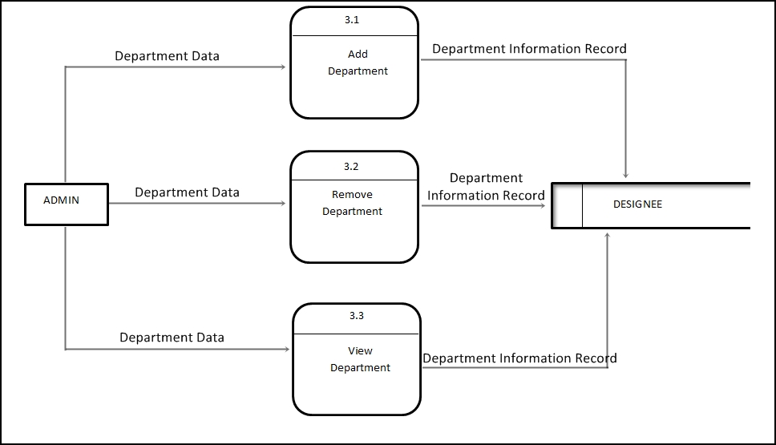**Figure 5. Level 1 Data Flow Diagram**

**Figure 6. Level 2 Data Flow Diagram**

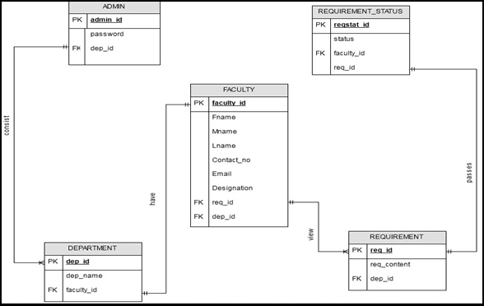**Entity Relationship Diagram**

**Figure 5. Entity Relationship Diagram**

The figure above shows the relationship of each entity on the table in the database of the proposed Online Faculty Clearance System. The relationship in the above tables is one-to-one, one-to-many and many-to-many relationships.